**DELHI TECHNOLOGICAL UNIVERSITY**



(Formerly Delhi College of Engineering)

Shahbad Daulatpur, Bawana Road, Delhi 110042

**DEPARTMENT OF SOFTWARE ENGINEERING**

**PROJECT**

**OBJECT ORIENTED SOFTWARE ENGINEERING**

**Under the supervision of : Submitted By:**

Prof. Ruchika Malhotra (HOD) Vikas Gupta

& Ms. Anjali Bansal 2K21/SE/192

Department of Software Engineering

INDEX

|  |  |  |  |
| --- | --- | --- | --- |
| **S. No.** | **EXPERIMENT** | **Page no.** | **Signature** |
| 1 | Problem statement : Railway Reservation System | 03 |  |
| 2 | Initial Requirement Documentation (IRD) | 04 |  |
| 3 | Software Requirements Specification (SRS) document | 05-10 |  |
| 4 | Use Case Diagram | 11 |  |
| 5 | Use Case Descriptions | 12-26 |  |
| 6 | Class Diagram | 27 |  |
| 7 | Sequence Diagrams | 28-32 |  |
| 8 | Activity Diagrams | 33-34 |  |
| 9 | State - Chart Diagrams | 35-36 |  |
| 10 | Test Case Scenario Matrix | 37-39 |  |

**Problem statement –**

Railway reservation system –

The Project on Railway website is aimed to involve users to search for and book for train tickets, view train schedules and availability, cancel or change reservations and potentially manage their rewards. The system would integrate with railways’s existing database and access real time train information of ticket fares, schedules, and seat availability. Limitations on prevalant current system are as follows-

* Lack of sufficient information such as cancellation charges, refund process and many other updates that is not available to the passengers.
* Lack of feedback due to which the railway community has to work upon to fill the loopholes.
* Poor navigation of the current status of train, delayed Information , etc.
* No proper updates of scheduling of trains and availability from boarding stations.

Features of the proposed system–

* Making more user-friendly & intitutive interface.
* Clear navigation for the updation of current status of train, and delayed information .
* Proper contact information through live chat-bot support system.
* Taking feedbacks from the passengers.
* Improvement in the interactive map of the train route.

**Initial Requirement Documentation (IRD) –**

|  |  |
| --- | --- |
| Title of the Project | Railway Reservation Website |
| Stakeholders involved in capturing requirements | Indian Railways , Customers ,Travel Agents , Railway Booking Officers , Project Manager |
| Techniques used for requirement capturing | Interviewing and brainstorming |
| Name of the persons | Vikas Gupta 2K21/SE/192 , Tejas Gahhlot 2K21/SE/182 |
| Date | 23 January, 2023 |
| Version | 1.0 |
| **Consolidated list of initial requirements:**   1. The website should allow Passengers/Indian Railways to create an account, log in, and manage their personal information. 2. The administrator shall be able to maintain all the information of platform and trains. 3. The website should provide up-to-date information on train schedules, including departure and arrival times, as well as real-time availability of seats for reservation. 4. The website should provide fare information for different classes of seats and trains. 5. The website should allow the passengers to book tickets, select seats, and make payments online. 6. The website should allow Passengers Indian Railways to check the status of their booking and the PNR number. 7. The website should allow passengers to cancel their reservations. 8. The website should be responsive and compatible with mobile devices. 9. The website should allow passengers Indian railways to add/delete/update the passengers list. 10. The website should allow passengers to initiate refund when the transaction failed. 11. The website should have high-level of security features to protect user's personal information and   transactions.   1. The website should provide reporting and analytics to track website usage and transactions. | |

**Software Requirements Specification (SRS) document for a railway reservation system:**

|  |  |  |
| --- | --- | --- |
| **1.** | **Introduction:** | |
| 1.1  1.2  1.3  1.4  1.5 | Purpose  Scope  Definitions, Acronyms and Abbreviations  References  Overview | |
| **2.** | **Overall Description:** | |
| 2.1  2.1.1  2.1.2  2.1.3  2.1.4  2.1.5  2.1.6  2.1.7  2.1.8  2.2  2.3  2.4  2.5  2.6 | Product Perspective  System Interfaces  User Interfaces  Hardware Interfaces  Software Interfaces  Communication Interfaces  Memory Constraints  Operations  Site Adaptation Requirements  Product Functions  User Characteristics  Constraints  Assumptions and Dependencies  Apportioning of Requirements | |
| **3.** | | **Specific Requirements:** |
| 3.1  3.1.1  3.1.2  3.1.3  3.1.4  3.2  3.3  3.4  3.5  3.6  3.7 | | External Interface Requirements  User Interfaces  Hardware Interfaces  Software Interfaces  Communication Interfaces  Functional Requirements  Performance Requirements  Design Constraints  Software System Attributes  Logical Database Requirements  Other Requirements |

**1.Introduction:-**

1.1 Purpose:

The purpose of this document is to specify the requirements for a railway reservation system. It outlines the features and functionalities that the system must provide to users.

1.2 Scope:

The railway reservation system is an online platform for booking train tickets, checking availability, and managing reservations. The system will allow users to search for trains, book tickets, cancel reservations, and manage their account information.

1.3 Definitions, Acronyms, and Abbreviations:

* SRS: Software Requirements Specification

1.4 References:

* Indian Railways website
* IRCTC website
* RailYatri website

1.5 Overview:

The railway reservation system is designed to make it easy for users to book train tickets, check availability, and manage their reservations. The system will provide a user-friendly interface that allows users to quickly search for trains, select the desired journey, and book tickets online.

**Overall Description:**

The Railway Reservation System is an online platform designed to simplify the process of booking train tickets in India. It interacts with external sources to retrieve train schedules, fares, and seat availability information, and integrates with payment gateways for secure payment. The user interface is intuitive and user-friendly, allowing users to search for available trains and book tickets easily. The system performs various operations, such as managing passenger details, cancelling bookings, and processing refunds. It is subject to various constraints, such as compliance with Indian Railways' rules and regulations.

2.1 Product Perspective:

The railway reservation system will be a standalone web application that will be accessible through a standard web browser. The system will use APIs to retrieve real-time information about trains and their schedules. The system will interface with payment gateways to process transactions and provide users with a secure platform for booking train tickets.

2.1.1 System Interfaces:

The system will use APIs to interface with external systems, including the Indian Railways website, IRCTC website, and RailYatri website.

2.1.2 User Interfaces:

The system will provide a user-friendly graphical user interface (GUI) that allows users to search for trains, book tickets, manage reservations, and view their transaction history.

2.1.3 Hardware Interfaces:

The system will require a computer or mobile device with a web browser and an internet connection to access the application.

2.1.4 Software Interfaces:

The system will use APIs to retrieve real-time information about trains and their schedules.

2.1.5 Communication Interfaces:

The system will use secure communication protocols, such as HTTPS, to ensure the privacy and security of user data.

2.1.6 Memory Constraints:

The system will be designed to operate efficiently on devices with limited memory.

2.1.7 Operations:

The system will perform operations such as searching for trains, booking tickets, and managing reservations.

2.1.8 Site Adaptation Requirements:

The system will be designed to be scalable and adaptable to accommodate changes in user traffic and demand.

2.2 Product Functions:

The railway reservation system will provide the following functions:

* User registration and authentication
* Train search and availability
* Booking and cancellation of tickets
* Payment processing
* Reservation management
* Transaction history

2.3 User Characteristics

The railway reservation system is designed for users who have basic computer literacy and are comfortable using a web browser.

2.4 Constraints

The railway reservation system must comply with the rules and regulations set by Indian Railways and other regulatory bodies. The system must also be designed to handle a high volume of user traffic.

2.5 Assumptions and Dependencies

The railway reservation system assumes that users have access to a computer or mobile device with a web browser and an internet connection. The system depends on external APIs to retrieve real-time information about trains and their schedules.

2.6 Apportioning of Requirements

The railway reservation system will be designed to accommodate future enhancements and new features, such as integration with other travel services and modes of transportation.

**Specific Requirements:**

3.1 External Interface Requirements:

3.1.1 User Interfaces:

The system will provide a user-friendly graphical user interface (GUI) that allows users to search for trains, book tickets, manage reservations, and view their transaction history. The GUI will be designed to be intuitive and easy to use, with clear navigation and search functions.

3.1.2 Hardware Interfaces:

The system will be accessible through a standard web browser on any computer or mobile device with an internet connection.

3.1.3 Software Interfaces:

The system will use APIs to interface with external systems, including the Indian Railways website, IRCTC website, and RailYatri website.

3.1.4 Communication Interfaces:

The system will use secure communication protocols, such as HTTPS, to ensure the privacy and security of user data.

3.2 Functional Requirements

3.2.1 User Registration

The system shall allow users to register for an account by providing their name, email address, mobile number, and password. Upon successful registration, the system shall send a verification email or SMS to the user's email or mobile number to authenticate their account.

3.2.2 User Login

The system shall allow registered users to log in to their account using their email or mobile number and password.

3.2.3 Book Ticket

The system shall allow users to search for available trains by providing the source and destination stations, travel dates, and preferred class of travel. The system shall display the available trains along with their schedules, fare, and seat availability. The user shall be able to select a train and book a ticket by providing their personal details, such as name, age, and gender, and payment information.

3.2.4 Maintain Train Details

The system shall maintain an up-to-date database of train schedules, fare, and seat availability. The system shall retrieve train details from external sources, such as Indian Railways or RailYatri, and update the database accordingly.

3.2.5 Maintain Passenger Details

The system shall maintain a database of passenger details, such as name, age, and gender, for each booking. The system shall allow users to update their passenger details or add new passengers to their account.

3.2.6 Pay Amount

The system shall integrate with payment gateways to allow users to pay for their bookings securely. The system shall provide multiple payment options, such as credit/debit cards, net banking, and mobile wallets, to users.

3.2.7 Cancel Ticket

The system shall allow users to cancel their ticket bookings and receive a refund according to the cancellation policy. The system shall verify the user's identity and cancel the booking accordingly.

3.2.8 Generate Ticket

The system shall generate a ticket for each successful booking, containing the passenger details, train details, and journey details. The system shall send the ticket to the user's email or mobile number as a PDF or image file.

3.2.9 Refund

The system shall calculate the refund amount for cancelled tickets based on the cancellation policy and refund the amount to the user's original payment method. The system shall send a notification to the user's email or mobile number about the refund status.

3.3 Performance Requirements:

The railway reservation system will be designed to handle a high volume of user traffic, with fast response times and minimal downtime. The system will be scalable and adaptable to accommodate changes in user traffic and demand.

3.4 Design Constraints:

The system must comply with the rules and regulations set by Indian Railways and other regulatory bodies. The system must also be designed to be accessible to users with disabilities.

3.5 Software System Attributes:

The railway reservation system will be designed to be secure, reliable, and user-friendly. The system will be able to handle a high volume of user traffic and provide fast response times.

3.6 Logical Database Requirements:

The system will maintain a database of user accounts, train schedules, seat availability, and transaction history. The database will be designed to be scalable and adaptable to accommodate changes in user traffic and demand.

3.7 Other Requirements:

The railway reservation system must comply with all applicable laws and regulations related to the collection and storage of user data. The system must also provide adequate documentation and support for users and administrators.

**USE CASE DIAGRAM & DESCRIPTION**

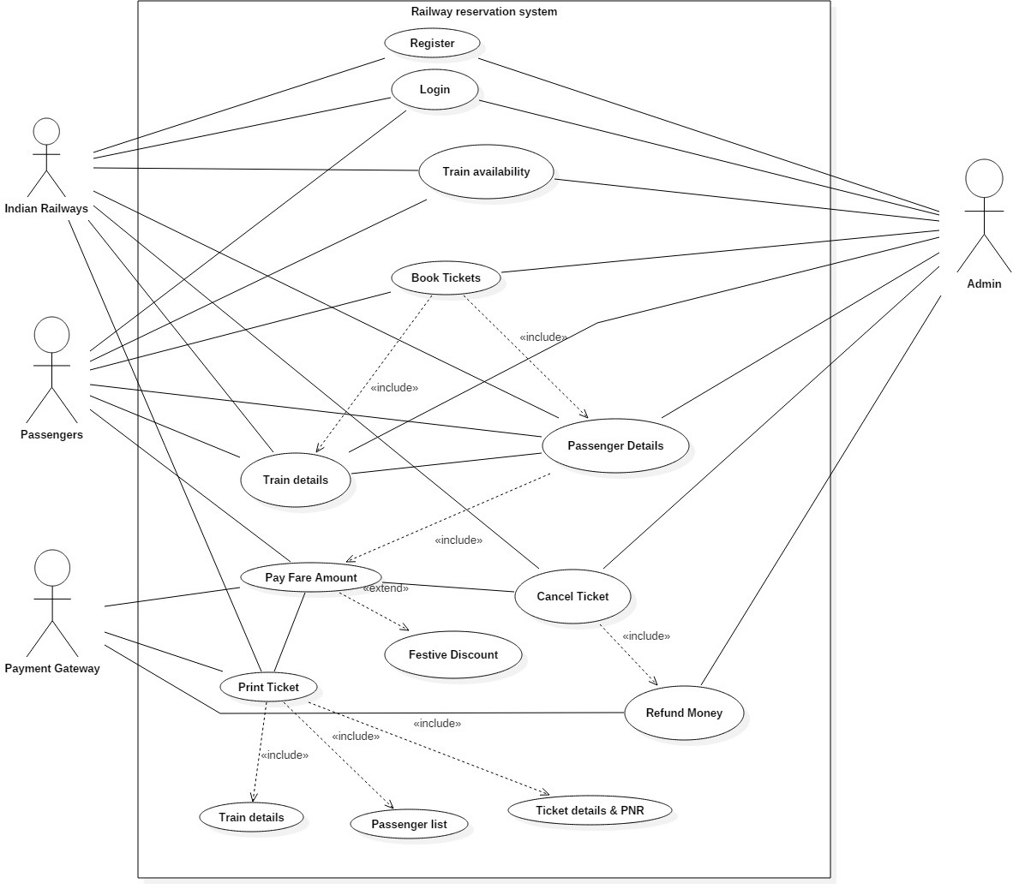

Use Case – Register

|  |  |
| --- | --- |
| Introduction | The user registers for the railway reservation system. |
| Actors | Railway system ,Passengers ,Admin |
| Pre-condition | * User should have a valid email address and phone number. * User should have basic information like name, age, gender, etc. |
| Post-condition | * User will be registered with the railway reservation system. * User will receive a confirmation email and SMS. |
| Event flow –  Basic Flow:   1. User opens the railway reservation system website. 2. User clicks on the “Register” button. 3. User enters the required personal information. 4. User clicks on the “Submit” button. 5. System validates the entered information. 6. System stores the user information. 7. System sends a confirmation email and SMS to the user. 8. User registration is complete. | |
| Alternate Flows:  Alternate Flow 1 – Session Expired:   * User session has expired due to inactivity. * System automatically logs the user out of the system.   Alternate Flow 2 – Technical Error:   * System encounters a technical error while processing the logout. * System displays an error message. * User retries the logout process. * System tries to process the logout again.   Alternate Flow 3 – Network Error:   * User has a weak internet connection. * System is unable to process the logout. * User troubleshoots the internet connection and retries the logout process | |
| Special Requirements - None | |
| Associated Use case- None | |

Use Case - LOGIN

|  |  |
| --- | --- |
| Introduction | Login is used to authenticate the user (Railway system and passengers) and enter into the system. |
| Actors: | * Passengers * Railway System * Admin |
| Pre-condition: | The user has a valid account in the railway reservation system. |
| Post-condition: | The user is granted access to the system's features and can perform railway reservation transactions. |
| Flow of Events -  Basic Flow:   1. The user accesses the railway reservation system. 2. The user enters his/her username and password. 3. The system verifies the user's credentials. 4. If the credentials are valid, the system grants access to the user and displays the main menu. | |
| Alternate Flow :  Alternate Flow 1 – Invalid credentials   * The system prompts the user to reset the password. * The user provides the required information to reset the password. * The system verifies the information and sends an email with instructions for resetting the password.   Alternate Flow 2 – User exits the window   * The credentials will get discarded. * The logged in used gets logged out. | |
| Special requirements - None | |
| Associated use case - None | |

Use Case: Book Ticket

|  |  |
| --- | --- |
| Introduction | The passenger books the ticket according to the availability and requirements of the user. |
| Actors: | * Passengers * Railway System * Admin |
| Pre-condition: | 1. The user has access to the railway reservation system.    2. The system has up-to-date information on train schedules and availability. |
| Post-condition: | The user can view the available trains for a specified route and date. |
| Event flow –  Basic Flow:   1. The user selects the "Train Availability" option in the main menu. 2. The user enters the origin, destination, and travel date. 3. The system displays a list of available trains for the specified route and date. 4. The user selects a train and views the available classes, seats, and fares. 5. The user can proceed further if desired. | |
| Alternate Flow:  Alternate Flow 1: No Trains Available   * The system indicates that no trains are available for the specified route and date. * The user is prompted to select a different route or date.   Alternate Flow 2: No Seats Available   * The system indicates that no seats are available for the specified route and date. * The user is prompted to select a different train or date. * The user modifies the search criteria and repeats the availability check.   Alternate Flow 3: Invalid Input   * The system indicates that the provided information is invalid. * The system displays an error message to inform the user about the invalid input. * The user is prompted to provide valid information.   Alternate Flow 4: System Failure   * The system encounters an unexpected error. * The system displays an error message to inform the user about the system failure.   Alternate Flow 5: Insufficient Permission   * The user attempts to perform the requested action. * The system detects that the user lacks the necessary permissions to perform the action. * The system displays an error message indicating insufficient permission. | |
| Special Requirements - None | |
| Associated Use case- None | |

Use Case: Maintain Train Details

|  |  |
| --- | --- |
| Introduction | All the Train details like train number, and route are to be maintained by the admin and the railway system |
| Actors: | * Passengers * Railway System * Admin |
| Pre-condition: | Admin must have the authority to maintain train information in the system |
| Post-condition: | The train details in the system are up to date and accurate. |
| Event flow –  Basic Flow:   1. Admin accesses the reservations system 2. Admin selects the option to maintain train details 3. System displays a list of trains available in the system 4. Admin selects the option to add, update, delete, view and search train details. 5. Basic Flow 1: Adding a new train  * Admin selects the option to add a new train * System displays a form to add new train information * Admin inputs the required information, including train name, route, schedule, and capacity * System validates the inputted information * System adds the train information to the system  1. Basic Flow 2: Updating train details  * Admin selects the option to update a train * System displays a list of trains available in the system * Admin selects the train for which they want to update information * System displays the current details of the selected train * Admin updates the train details as required * System validates the updated information * System updates the train information in the system  1. Basic Flow 3: Deleting train details  * Admin selects the option to delete a train * System displays a list of trains available in the system * Admin selects the train to delete * System displays a confirmation prompt to verify the Admin's intention to delete the train information * Admin confirms the deletion request * System removes the train information from the system  1. Basic Flow 4: Viewing train details  * System displays a list of trains available in the system * Admin/Passengers selects the train for which they want to view details * System displays the train details, including train name, route, schedule, and capacity  1. Basic Flow 5: Searching for a train  * Admin/Passengers selects the option to search for a train * System displays a search form * Admin/Passengers inputs the search criteria, such as train name, route, or schedule * System searches the system for trains that match the search criteria * System displays a list of matching trains * System displays the train details, including train name, route, schedule, and capacity | |
| Alternate Flow:  Alternate Flow 1: Already Existing Details -   * If the Admin attempts to add or update information for an already existing train, the system will display an error message and not allow the add or update.   Alternate Flow 2: Validation Issue-   * If there is an issue with validating the inputted or updated information, the system will display an error message and provide instructions for the Admin to correct the information. * If the Admin attempts to delete a non-existent train, the system will display an error message and not allow the delete.   Alternate Flow 3: Invalid Input   * The system indicates that the provided information is invalid. * The system displays an error message to inform the user about the invalid input. * The user is prompted to provide valid information.   Alternate Flow 4: System Failure   * The system encounters an unexpected error. * The system displays an error message to inform the user about the system failure.   Alternate Flow 5: Insufficient Permission   * The user attempts to perform the requested action. * The system detects that the user lacks the necessary permissions to perform the action. * The system displays an error message indicating insufficient permission. | |
| Special Requirements - None | |
| Associated Use case- None | |

Use Case: Maintain Passenger Details

|  |  |
| --- | --- |
| Introduction | All the Passenger details like PNR number are to be maintained by the admin, passenger and the railway system |
| Actors: | * Passengers * Railway System * Admin |
| Pre-condition: | The user has access to the railway reservation system |
| Post-condition: | The user's passenger information is added, updated, or deleted in the system as required. |
| Event flow –  Basic Flow:   1. The user selects the "Maintain Passenger Details" option in the main menu.   Basic Flow 1: Adding passenger details   * User selects the "Add Passenger Details" option. * User provides the required passenger information, such as name, age, gender, etc. * System verifies the information and adds the passenger details to the system. * System displays a confirmation message with the passenger's unique ID.   Basic Flow 2: Updating passenger details   * User selects the "Update Passenger Details" option. * User provides the passenger's unique ID. * System displays the current passenger information. * User modifies the required information. * System updates the passenger information and displays a confirmation message.   Basic Flow 3: Deleting passenger details   * User selects the "Delete Passenger Details" option. * User provides the passenger's unique ID. * System displays the current passenger information. * User confirms the deletion. * System deletes the passenger information and displays a confirmation message.   Basic Flow 4: Viewing passenger details   * User selects the "View Passenger Details" option. * System displays a list of all passenger details. * User selects a specific passenger from the list. * System displays the passenger's details.   Basic Flow 5: Searching for passenger details   * User selects the "Search Passenger Details" option. * User provides the search criteria, such as name, age, gender, etc. * System searches the passenger details based on the provided criteria. * System displays the matching passenger details. | |
| Alternate Flow:  Alternate Flow 1: Invalid Details -   1. The system indicates that the provided information is invalid. 2. The user is prompted to provide valid information. 3. The user repeats the process.   Alternate Flow 2: Error Occurred   1. If the system not adds, updates, or deletes the passenger information and it displays an error message.   Alternate Flow 3: Invalid Input   * The system indicates that the provided information is invalid. * The system displays an error message to inform the user about the invalid input. * The user is prompted to provide valid information.   Alternate Flow 4: System Failure   * The system encounters an unexpected error. * The system displays an error message to inform the user about the system failure.   Alternate Flow 5: Insufficient Permission   * The user attempts to perform the requested action. * The system detects that the user lacks the necessary permissions to perform the action. * The system displays an error message indicating insufficient permission. | |
| Special Requirements - None | |
| Associated Use case- None | |

Use Case: Pay Fare Amount

|  |  |
| --- | --- |
| Introduction | The passenger will pay the fare of the ticket. |
| Actors: | * Passengers * Railway System * Admin |
| Pre-condition: | 1. The user has access to the railway reservation system.  2. The user has successfully booked a ticket and is ready to make payment. |
| Post-condition: | The user has successfully paid the fare amount for the booked ticket |
| Event flow –  Basic Flow:   1. The user selects the "Pay Fare" option in the main menu. 2. The user provides the ticket reservation number. 3. The system displays the ticket details and the fare amount. 4. The user selects a payment method (e.g.credit/debit card, net banking, etc.). 5. The user provides the required payment information. 6. The system processes the payment and displays a payment receipt. | |
| Alternate Flow:  Alternate Flow 1: Payment Fails -   * The payment fails. * The system displays an error message and prompts the user to repeat the payment process. * The user repeats the payment process and makes a new payment attempt.   Alternate Flow 2: Invalid Input   * The system indicates that the provided information is invalid. * The system displays an error message to inform the user about the invalid input. * The user is prompted to provide valid information.   Alternate Flow 3: System Failure   * The system encounters an unexpected error. * The system displays an error message to inform the user about the system failure.   Alternate Flow 4: Insufficient Permission   * The user attempts to perform the requested action. * The system detects that the user lacks the necessary permissions to perform the action. * The system displays an error message indicating insufficient permission. | |
| Special Requirements - None | |
| Associated Use case- None | |

Use Case: Cancel Ticket

|  |  |
| --- | --- |
| Introduction | The passenger, user can cancel the ticket. |
| Actors: | * Passengers * Railway System * Admin |
| Pre-condition: | 1. Customer must have a valid reservation  2. Cancellation must be done before the scheduled departure time |
| Post-condition: | 1. The reservation is cancelled and the ticket is no longer valid  2. Refund, if applicable, is processed and credited to the customer's account |
| Event flow –  Basic Flow:   1. Customer accesses the reservations system 2. Customer selects the option to cancel a reservation 3. System prompts the customer to enter their reservation details 4. System verifies the reservation and displays the reservation details for the customer to confirm 5. Customer confirms the cancellation 6. System processes the cancellation and initiates the refund, if applicable 7. System displays a confirmation of the cancellation and refund details | |
| Alternate Flow:  Alternate Flow 1: Delayed cancellation-   * If the customer attempts to cancel after the scheduled departure time, the system will not allow the cancellation and display an error message.   Alternate Flow 2: Incorrect details-   * If the customer enters incorrect reservation details, the system will display an error message and prompt the customer to re-enter the details.   Alternate Flow 3: Customer support-   * If there is an issue with processing the refund, the system will display an error message and provide instructions for the customer to contact customer support.   Alternate Flow 4: System Failure   * The system encounters an unexpected error. * The system displays an error message to inform the user about the system failure. | |
| Special Requirements - None | |
| Associated Use case- None | |

Use Case: Generate Ticket

|  |  |
| --- | --- |
| Introduction | The passenger, user can generate the ticket. |
| Actors: | * Railway System * Payment gateway |
| Pre-condition: | Customer must have a confirmed reservation |
| Post-condition: | The customer has a printed copy of the ticket, including ticket details and PNR, passenger list, and train details |
| Event flow –  Basic Flow:   1. Customer accesses the reservations system 2. Customer selects the option to print a ticket 3. System prompts the customer to enter their reservation details, including the PNR number 4. System retrieves the reservation information, including ticket details, passenger list, and train details 5. System displays the ticket details, including  * PNR * passenger list * train details for the customer to confirm  1. Customer confirms the print request 2. System generates a printable copy of the ticket, including ticket details, PNR, passenger list, and train details 3. System displays a confirmation of the print request 4. Customer prints the ticket | |
| Alternate Flow:  Alternate Flow 1: Not Generating printable copy-   * If the customer attempts to print a ticket for a non-confirmed reservation, the system will not allow the print request and display an error message. * If there is an issue with generating the printable copy, the system will display an error message and provide instructions for the customer to contact customer support.   Alternate Flow 2: System Failure   * The system encounters an unexpected error. * The system displays an error message to inform the user about the system failure. | |
| Special Requirements - None | |
| Associated Use case- None | |

Use Case: Refund Money

|  |  |
| --- | --- |
| Introduction | The passenger, user can generate the ticket. |
| Actors: | * Passenger * Railway System * Payment gateway |
| Pre-condition: | 1. Customer must have a cancelled reservation  2. Refund policy must allow for a refund |
| Post-condition: | The customer's account is credited with the refund amount |
| Event flow –  Basic Flow:   1. Customer accesses the reservations system 2. Customer selects the option to request a refund 3. System prompts the customer to enter their reservation details 4. System verifies the reservation and displays the cancellation details 5. System calculates the refund amount based on the cancellation and refund policy 6. System displays the refund amount for the customer to confirm 7. Customer confirms the refund request 8. System processes the refund and credits the customer's account 9. System displays a confirmation of the refund | |
| Alternate Flow:  Alternate Flow 1:- Refund Not Initiated -   * If the customer attempts to request a refund for a non-cancelled reservation, the system will not process the request and display an error message. * If the refund policy does not allow for a refund, the system will display a message indicating that no refund is available. * If there is an issue with processing the refund, the system will display an error message and provide instructions for the customer to contact customer support.   Alternate Flow 2: System Failure   * The system encounters an unexpected error. * The system displays an error message to inform the user about the system failure. | |
| Special Requirements - None | |
| Associated Use case- None | |

Use Case: Logout

|  |  |
| --- | --- |
| Introduction | The user gets logged out from the system. |
| Actors | Railway system, Passengers, Admin |
| Pre-condition | * User should have a valid session with the railway reservation system |
| Post-condition | * User session with the railway reservation system will be terminated. * User will be logged out of the system. |
| Event flow –  Basic Flow:   1. User opens the railway reservation system website. 2. User clicks on the “Logout” button. 3. System terminates the user’s session. 4. User is logged out of the system. | |
| Alternate Flows:  Alternate Flow 1- Invalid Information:   * System displays an error message. * Already Registered Email/Phone Number:   Alternate Flow 1- Technical Error:   * System encounters a technical error while processing the registration. * System tries to process the registration again.   Alternate Flow 3-Network Error:   * User has a weak internet connection. * System is unable to process the registration. * User troubleshoots the internet connection and retries the registration process. | |
| Special Requirements - None | |
| Associated Use case- None | |

**CLASS DIAGRAM -**

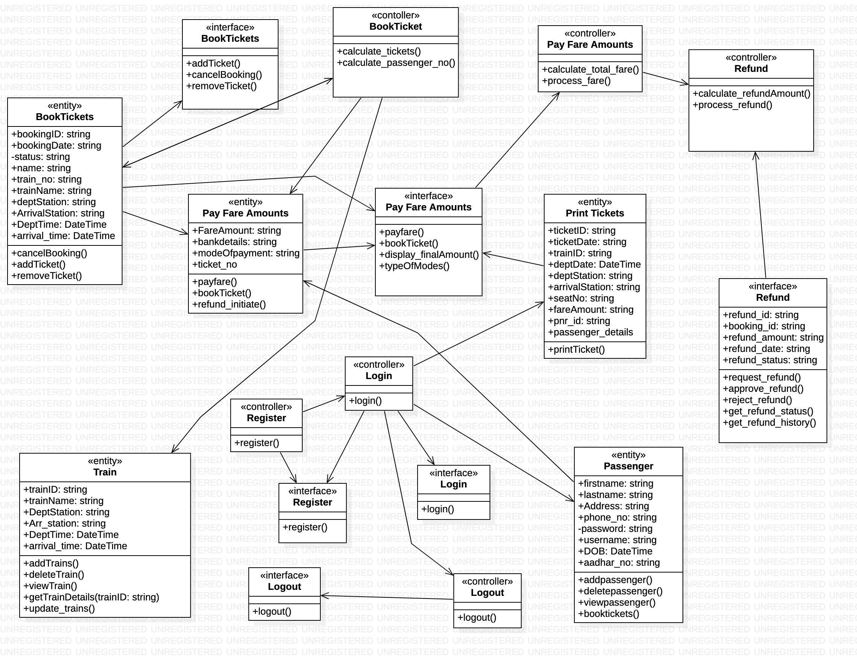

**SEQUENCE DIAGRAMS –**

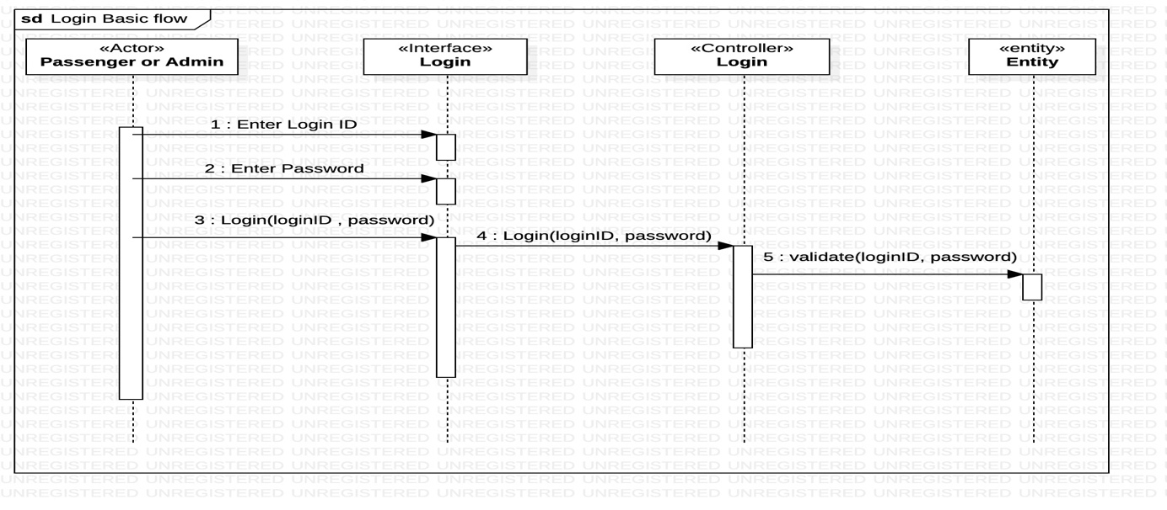

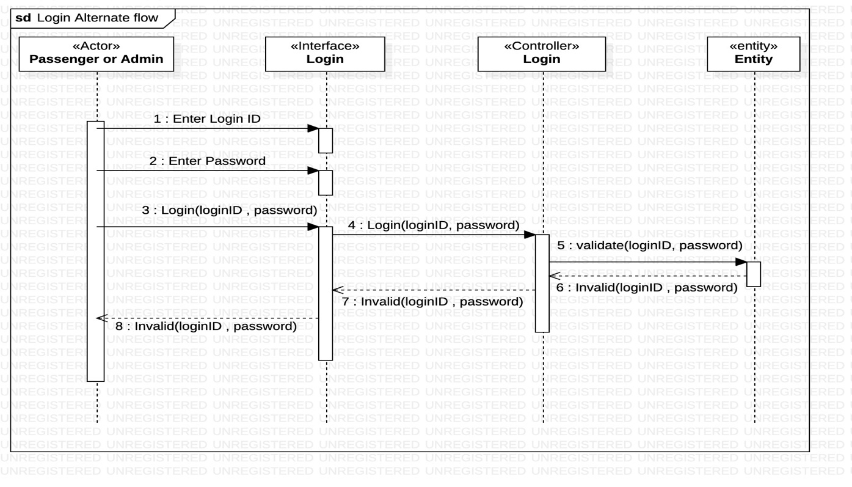

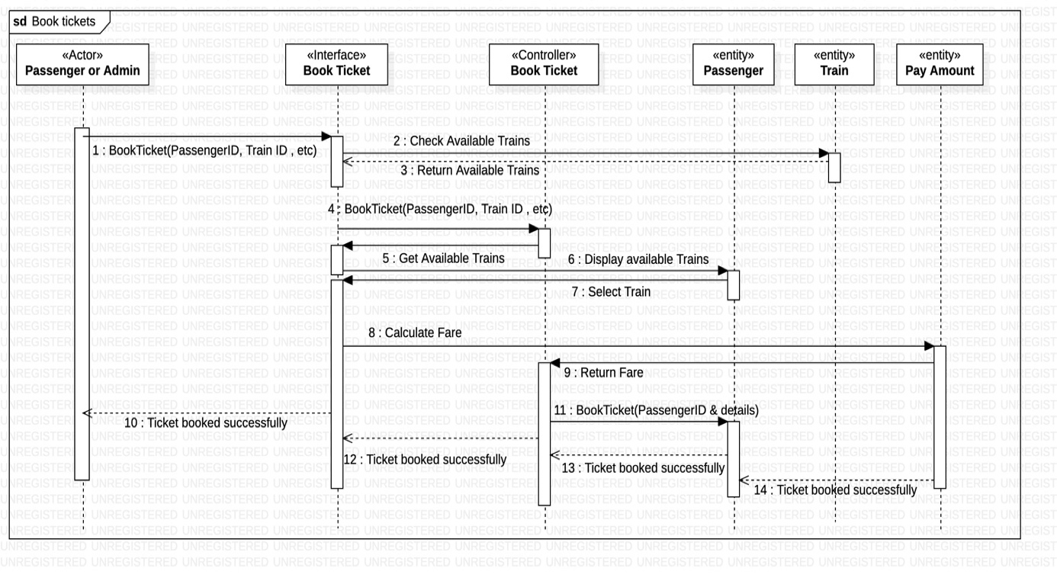

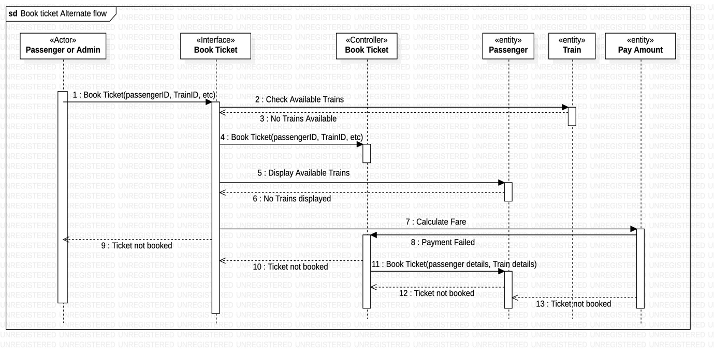

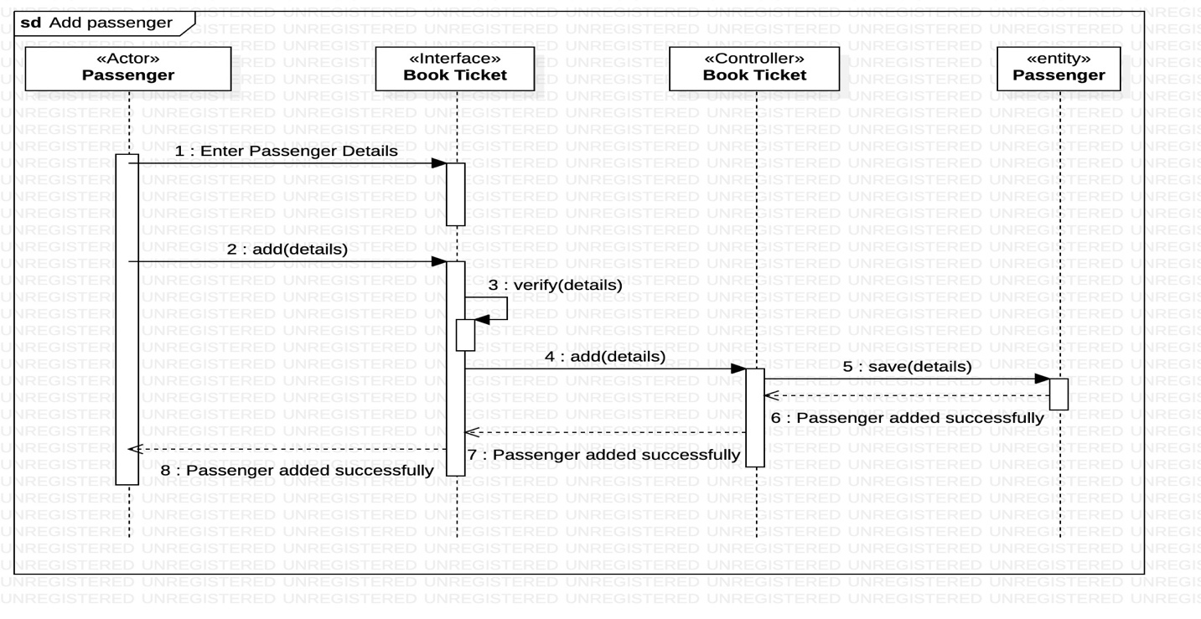

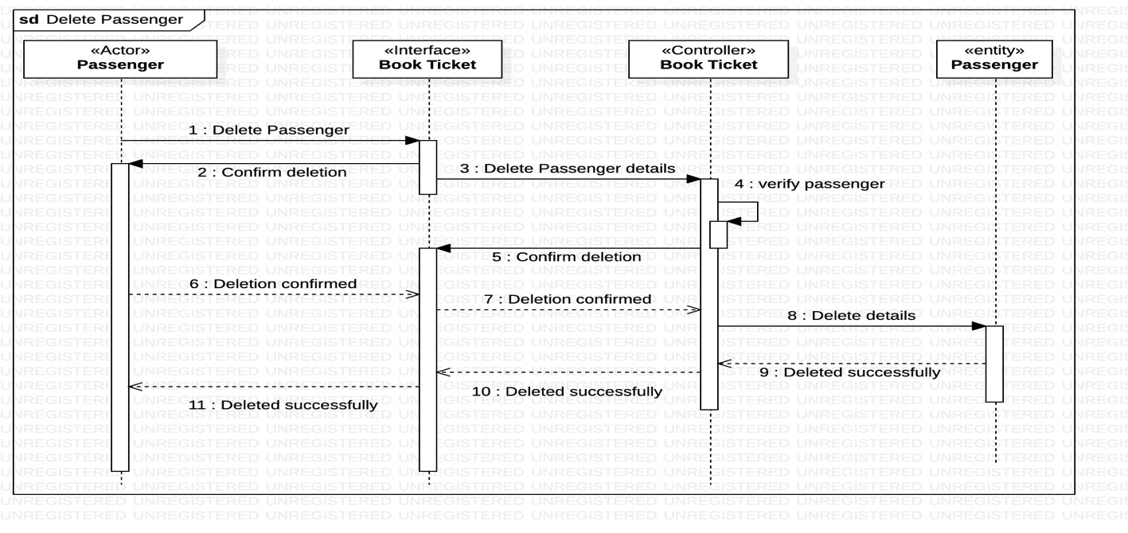

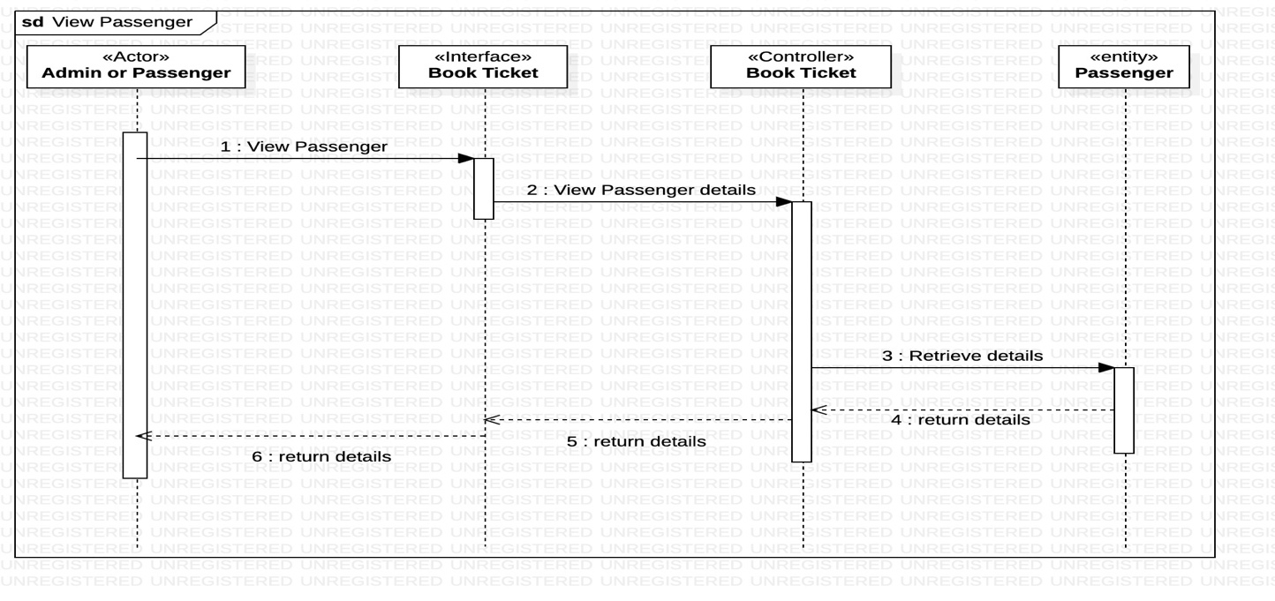

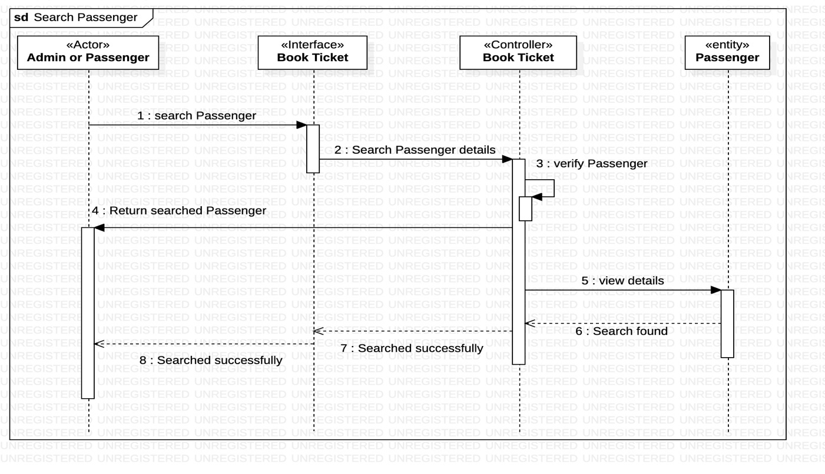

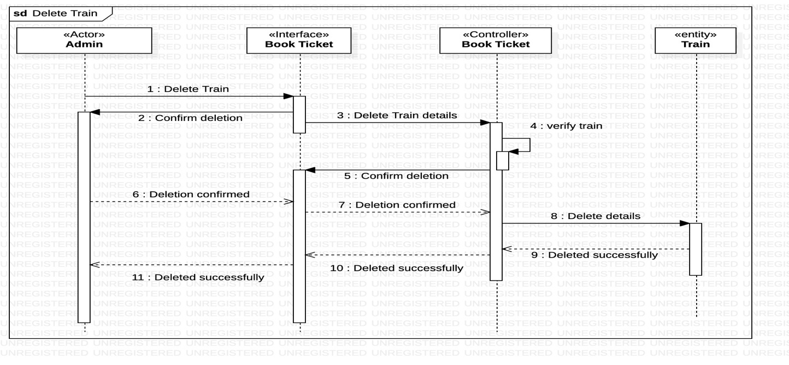

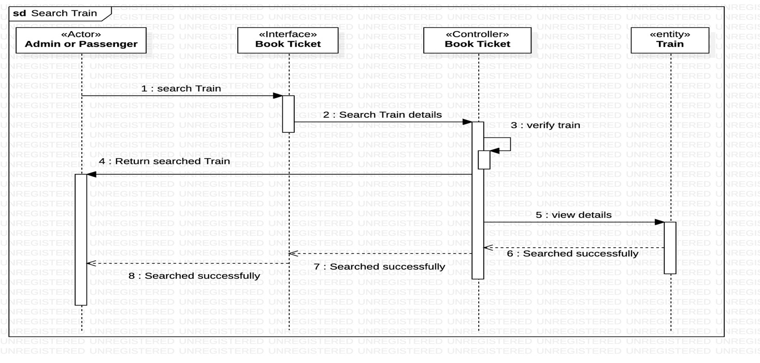

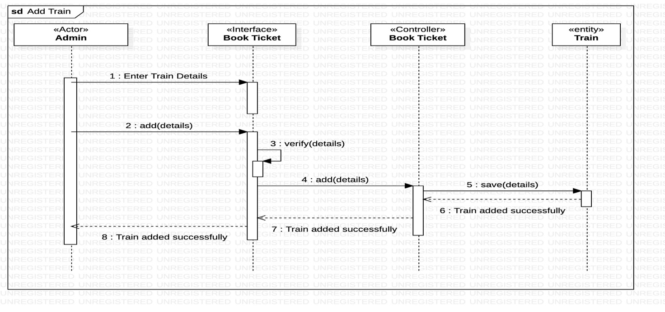

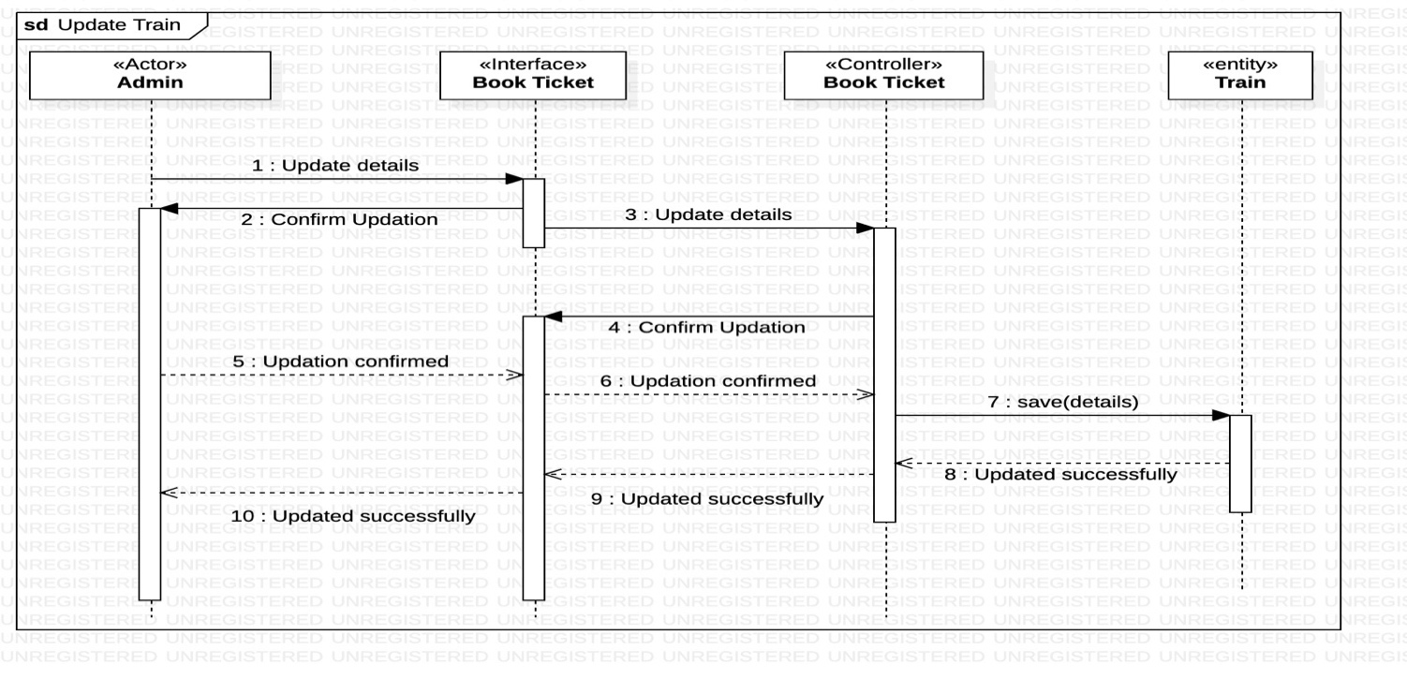

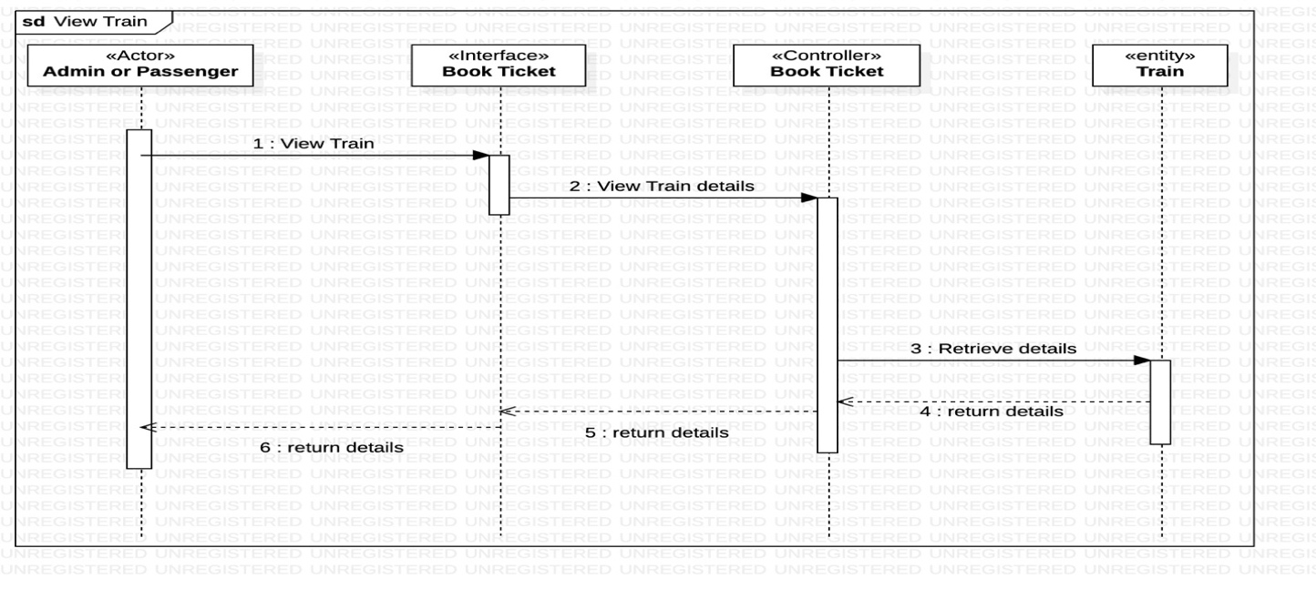

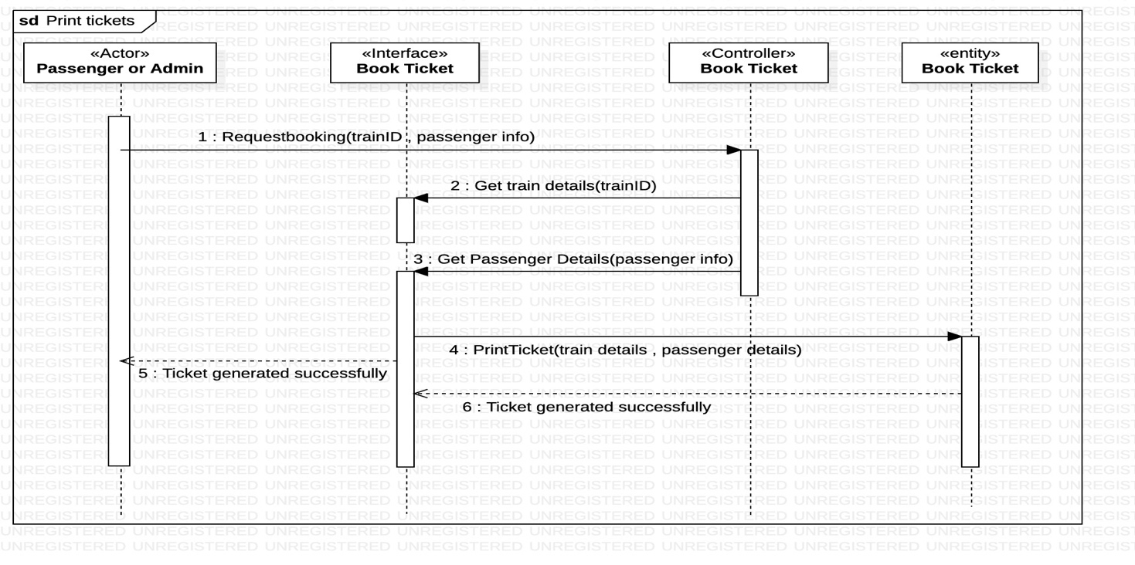

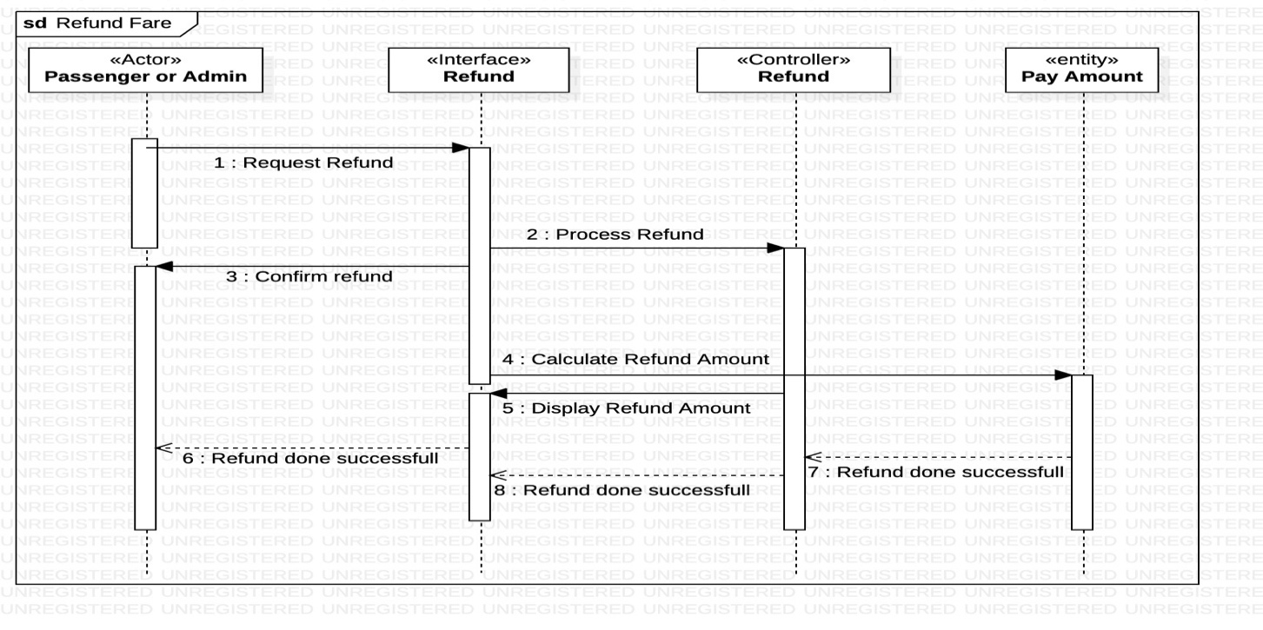

**ACTIVITY DIAGRAMS –**

**1. Maintain Passenger details -**

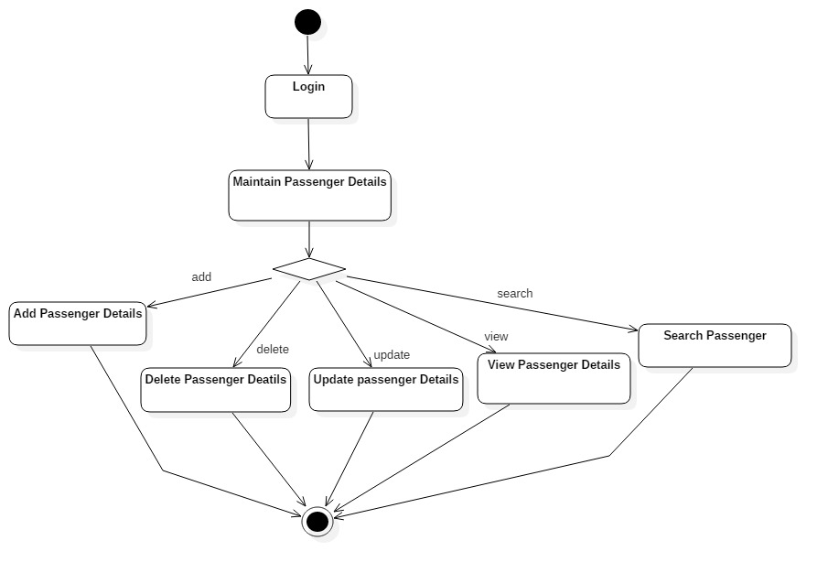

**2. Maintain Train Details –**

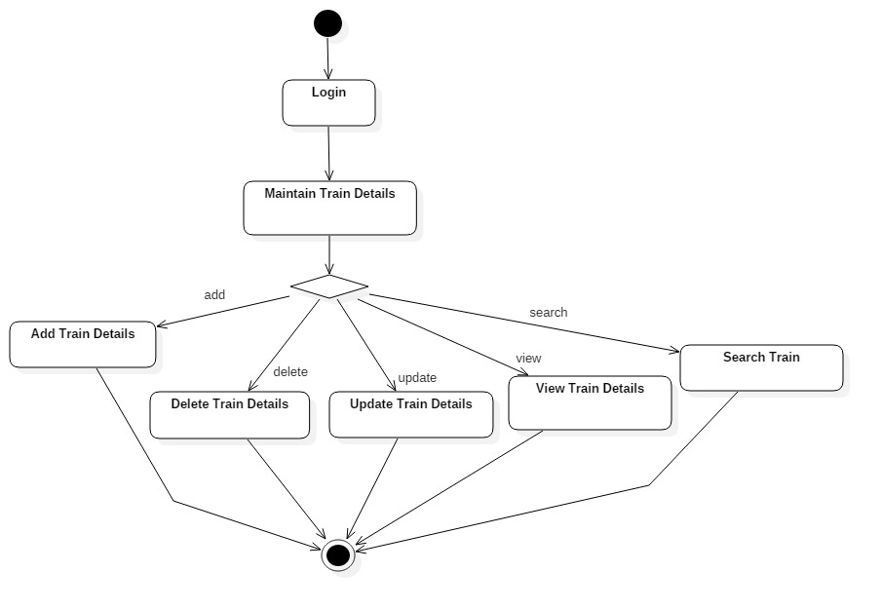

**3.Pay Fare Amount –**

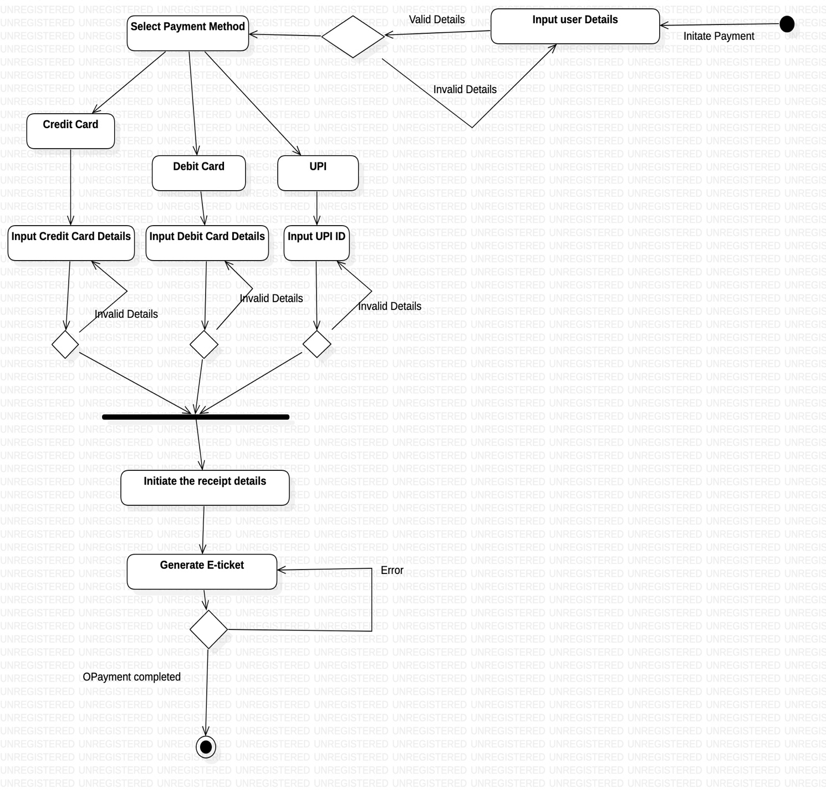

**STATE CHART DIAGRAMS**

**Login –**

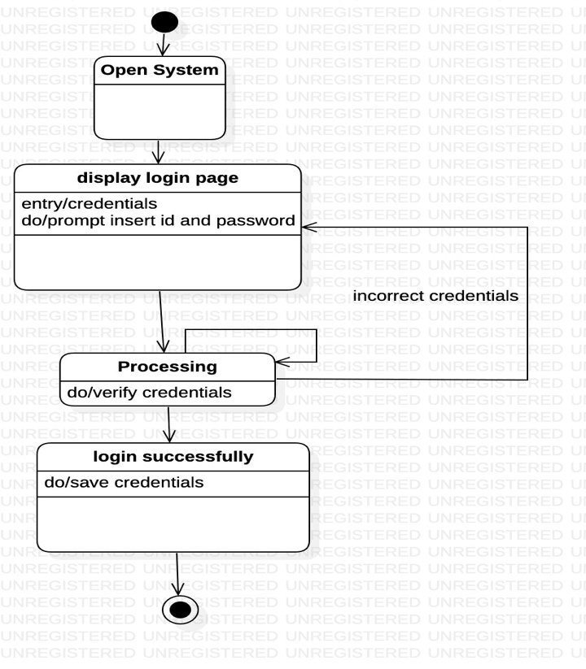

**Payment –**

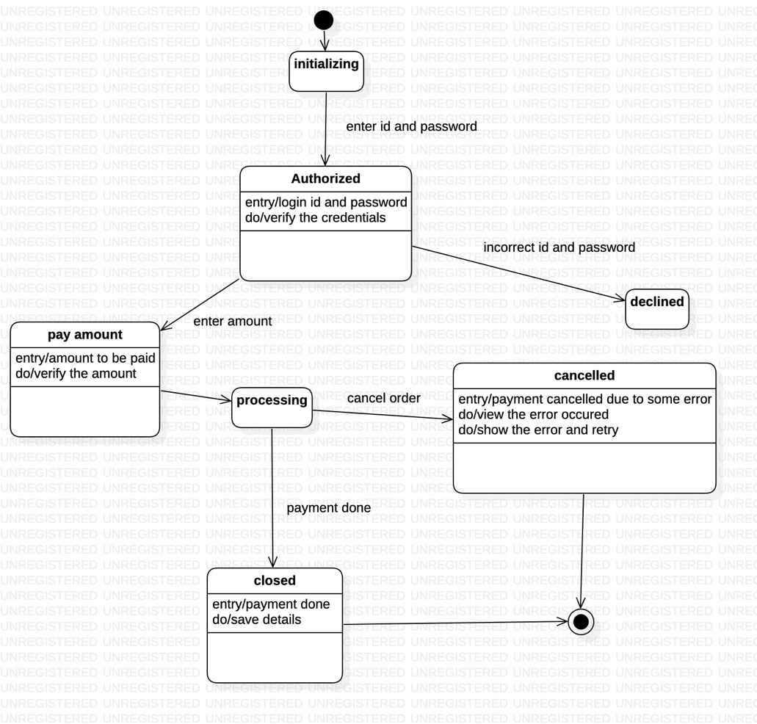

**Maintain Train Details-**

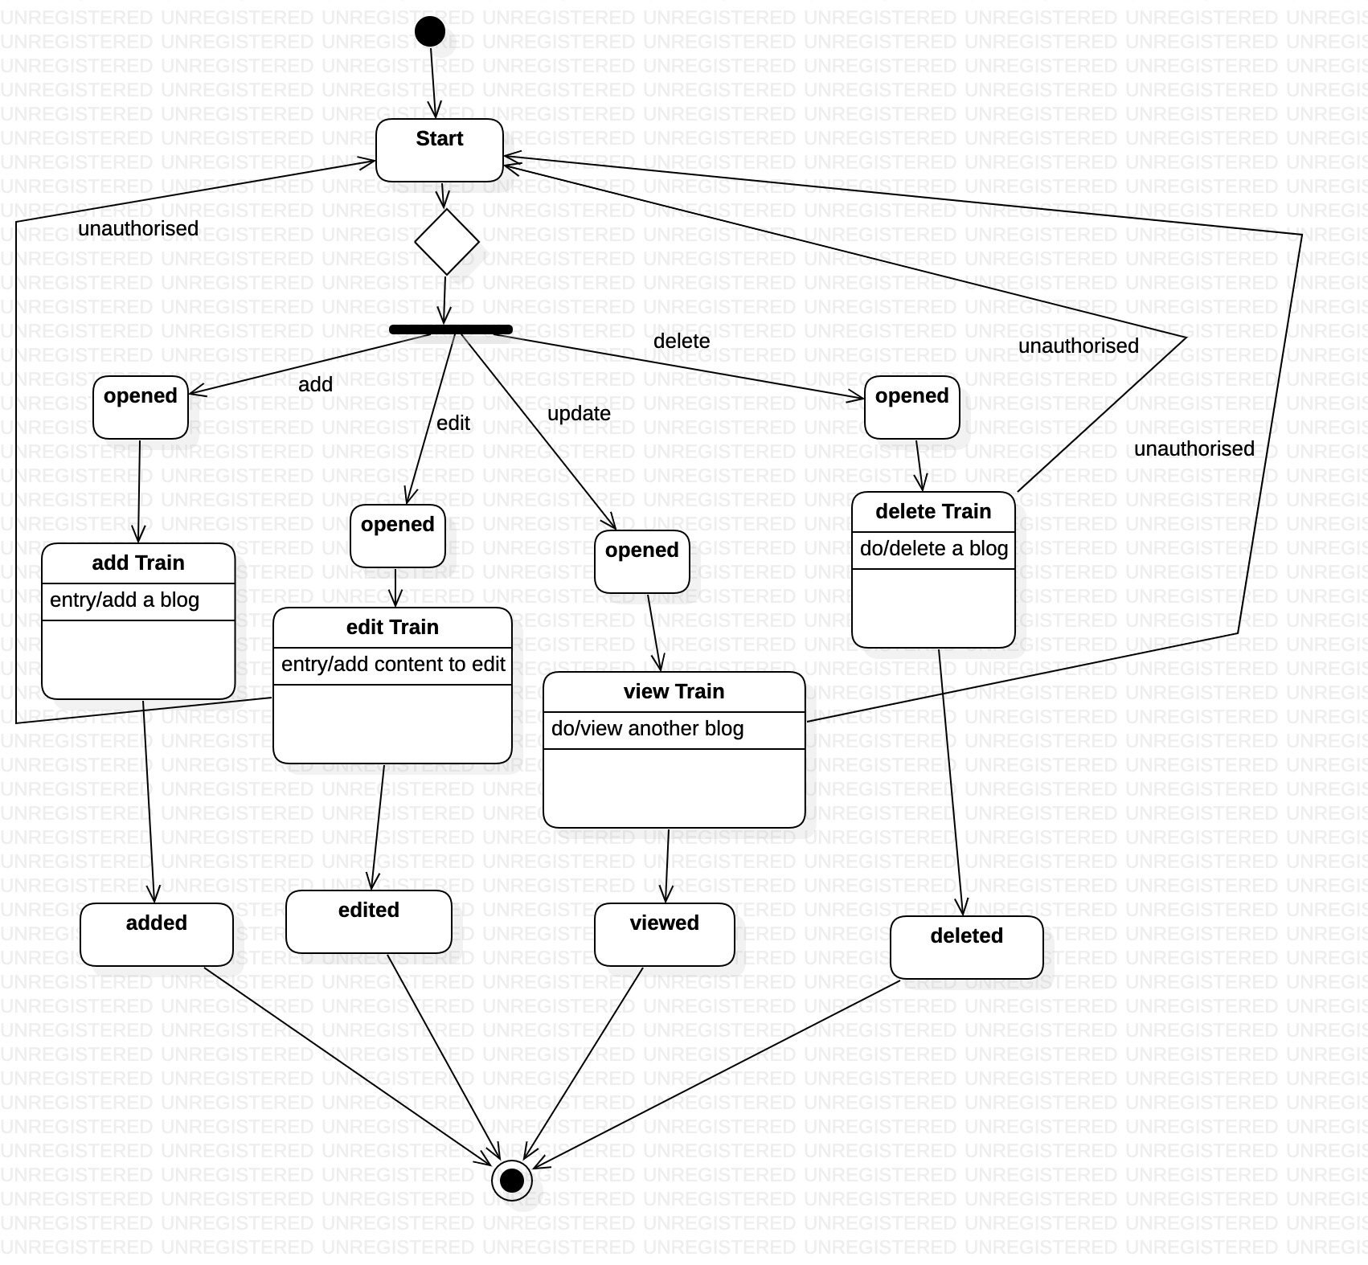

**TEST CASE SCENARIO MATRIX –**

**Login**

|  |  |  |  |  |  |  |
| --- | --- | --- | --- | --- | --- | --- |
| Test Case ID | Scenario Name & Description | Email ID | Password | Expected Output | Actual Output | Remarks |
| TC1 | Scenario 1 – Basic Flow | [noname@gmail.com](mailto:noname@gmail.com) | 12345678 | Login Successful! | Login Successful! | - |
| TC2 | Scenario 2 -  Account Doesn’t Exist | [yesname@gmail.com](mailto:yesname@gmail.com) | 12345678 | Account Doesn’t Exist! | Account Doesn’t Exist! | An account with the given email can not be found in the database |
| TC3 | Scenario 3 -  Invalid Credentials | noname$gmail.com | 13124 | Invalid Credentials! | Invalid Credentials! | Format of email ID is incorrect; it contains a ‘@’ sign AND a period (.) |
| TC4 | Scenario 4 -  Incorrect Password | [noname@gmail.com](mailto:noname@gmail.com) | 1234556789 | Password does not match! | Password does not match! | Password does not match to the corresponding email as in the database |

**Payment**

|  |  |  |  |  |  |  |  |
| --- | --- | --- | --- | --- | --- | --- | --- |
| Test Case ID | Scenario Name & Description | Card number | Expiry Date | CVV | Expected Output | Actual Output | Remarks |
| TC1 | Scenario 1 -  Basic Flow | 12345678901234 | 07/26 | 748 | Valid Details! Redirecting... | Valid Details! Redirecting... | - |
| TC2 | Scenario 2 -  Invalid Card number I | 1234567890 | 07/26 | 748 | Invalid Card number | Invalid Card number | Card number must be of 12 digits |
| TC3 | Scenario 3 -  Invalid Card number II | 1234567890ABCD | 07/26 | 748 | Invalid Card number | Invalid Card number | Card number must not contain any character |
| TC4 | Scenario 4 -  Card Expired | 12345678901234 | 07/22 | 748 | Card Expired | Card Expired | Card’s expiry date must be after the current date |
| TC5 | Scenario 5 -  Invalid CVV | 12345678901234 | 07/26 | 7485 | Invalid CVV | Invalid CVV | CVV contains only numbers from 10 – 999 |

**Book -**

|  |  |  |  |  |  |  |  |
| --- | --- | --- | --- | --- | --- | --- | --- |
| Test Case ID | Scenario Name & Description | Booking_ID | Tickets Booked | Discout Code | Expected Output | Actual Output | Remarks |
| TC1 | Scenario 1 -  Basic Flow | 1234567890 | 2 | SAFARKRO | Redirecting to payment page | Redirecting to payment page | - |
| TC2 | Scenario 2 -  Alternate Flow | 1234567890 | 2 |  | Redirecting to payment page | Redirecting to payment page | - |
| TC3 | Scenario 3 -  Tickets Not Available | 1234567890 | 1,000 | SAFARKRO | Capacity overflow. Please reduce and try again | Capacity overflow. Please reduce and try again | Capacity of added tickets exceeds amount in database |
| TC4 | Scenario 4 -  Invalid Booking ID | 1234567D7 | 2 | SAFARKRO | Invalid booking details, please try again and check the details | Invalid booking details, please try again and check the details | The system might generate invalid ID for booking. |
| TC5 | Scenario 5 -  Invalid Discount code | 1234567890 | 2 | FRIDAYNO | Invalid discount code, please enter correct code | Invalid discount code, please enter correct code | The user might enter a discount code that is not valid |

**Maintain Train Details -**

|  |  |  |  |  |  |  |  |  |  |
| --- | --- | --- | --- | --- | --- | --- | --- | --- | --- |
| Test Case ID | Scenario Name & Description | Train ID | Capacity | Running Time | Name | Images | Expected output | Actual Output | Remarks |
| TC1 | Scenario 1 -  Add Train Basic flow | <<self assigned>> | 500 | 12 hrs | Nazi Express | Image.jpg | Train added successfully | Train added successfully | - |
| TC2 | Scenario 2 -  Add Train alternate flow: Invalid input | <<self assigned>> | 500 | 100 hrs | Nazi Express | Image.jpg | Time Exceeds limit | Time Exceeds limit | Time of Train can not exceed 48 hrs |
| TC3 |  | <<self assigned>> | 20000 | 12 hrs | Nazi Express | Image.jpg | Capacity Exceed limit | Capacity Exceed limit | Capacity can not exceed 3000 |
| TC4 |  | <<self assigned>> | 500 | 12 hrs | Nazi Express | Image.png | - | - | Only jpg images can be added |
| TC5 | Scenario 3 -  Add Train alternative flow: Train exists | << self assigned>> | 500 | 12 hrs | Nazi Express | Image.jpb | Train already exists | Train already exists | Two Trains with the same name cannot exist in the database |
| TC6 | Scenario 4 -  Add Train Alternate flow: user exits | <<self assigned>> | 500 | 12 hrs | Nazi Express | Image.jpg | Train added successfully | Train added successfully | User can exit at any time |
| TC7 | Scenario 5 – Delete Train Basic flow | 123456789 | - | - | - | - | Train Deleted | Train Deleted | - |
| TC8 | Scenario 6 – Delete Train alternate flow: Train does not exist | 123456000 | - | - | - | - | Train does not exist | Train does not exist | Train ID does not exist, hence can not be deleted |
| TC9 | Scenario 7 – Delete Train alternate flow: user exits | 123456789 | - | - | - | - | - | - | User can exit at any time |
| TC10 | Scenario 8 -Update Train basic flow | 123456789 |  |  |  |  |  |  |  |